1. 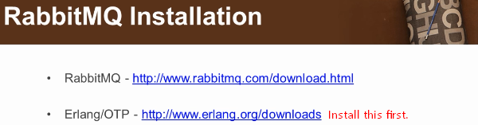 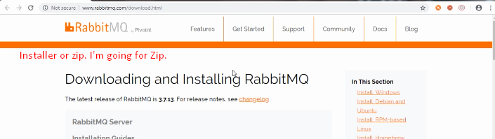
2. 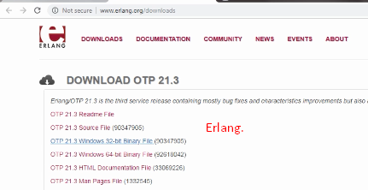
3. 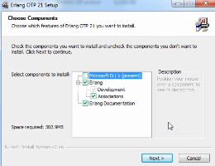
4. Setting **ERLANG_HOME**🡺 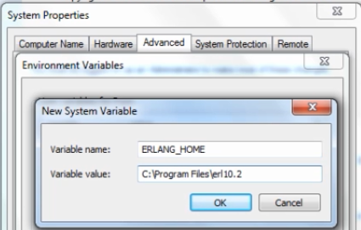
5. **Setting path**🡺
6. **Before** staring RabbitMQ server on host, we need to enable RabbitMQ management plugin. 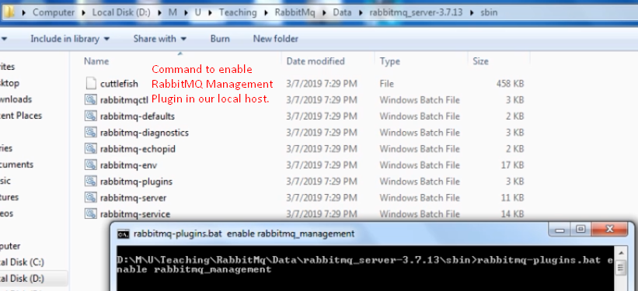
7. 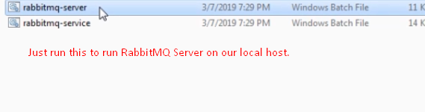
8. 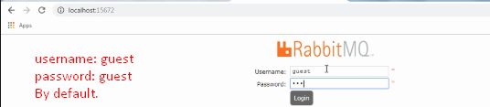
9. RabbitMQ management is user-friendly interface.  
   